The Origin of the Jaredites

Dr. Hugh Nibley was indispensible for the informed reader of the Book of Mormon. Geographers, travelers, Biblical scholars, historians, have all been called upon to reinforce the geography of the Book of Mormon. There are minor differences as to the travels of Levi from Jerusalem to the new world. Hugh Nibley gives a remarkable and detailed background to justify the first record of Nephi. It is not too difficult because the origin is given in the Book of Mormon and there is no debate as to where ancient Jerusalem was. With a clear record in the Book of Mormon it becomes almost elementary.

The story of the Jaredites, on the other hand has much to be desired. Even though the Book of Mormon gives the origin as the Jaredites as coming from Tower of Babel, history and archeology has no idea where the city of Babel resided and the story cannot be verified. Dr. Hugh Nibley’s account makes a grand assumption that the city of Babel was in Babylon. This is of course not as scientific as one might assume, but is based on religious tradition. Nibley took almost twenty pages before he made this assumption. From here he argued about his conclusion as a religious literalist. There was not one geographical comparison to anything specific or historically verifiable fact. Nibley could not even determine weather the Jaredites went west or east to Central America. There was nothing logical given. He mention geographical city names and customs manifest in the few pages of the Book of Mormon, but nothing geographical as used in the travels of Lehi. I argued the point with a Mormon archeologist, but all he could say that a city name from Babylon was also a name used by the Jaredites. That is like saying the small town of Kolob in Sothern Utah is the place where God dwells or that Paris N.Y. is the same as Paris France. I mentioned in the previous article that communication and perhaps traveling between ancient Sumer and ancient Egypt was common.

To justify an easterly direction, Nibley referred to ancient facts that there were many lakes across Asia through China and to justify a westerly direction he referred to the westerly ocean along the equator, but how would they get through Africa when the record says that the Jaredites went north down into the valley of Nimrod. This is close to the Mediterranean Sea. Although a start, the Jaredites traveled into the wilderness where now man has gone. This could not be East because there was a great civilization in the mount of the east.

The Jaredite migration comes from the *Book of Mormon* and indicates they came from the Great Tower and ended up in Central America. In looking at the record, it can be determined that they came from the Great Pyramid. Mormon gives an account of the Jaredite record from the “tower down” to their destruction. Mormon emphasized the confounding of languages that caused the Jaredites to call upon the Lord and spare their knowledge that they be not confounded. The Lord replied and asked the bother of Jared to gather their flocks of every kind and seed of every kind. This included the family and friends of Jared.

[Ether 1:42](https://www.lds.org/scriptures/bofm/ether/1.42?lang=eng#41)

And when thou hast done this thou shalt go at the head of them down into the valley which is northward. And there will I meet thee, and I will go before thee into a land which is choice above all the lands of the earth.

[Ether 2:1](https://www.lds.org/scriptures/bofm/ether/2.1?lang=eng#1)

And it came to pass that Jared and his brother, and their families, and also the friends of Jared and his brother and their families, went down into the valley which was northward, (and the name of the valley was Nimrod, being called after the mighty hunter) with their flocks…

It takes both verses to realize that the valley north is the valley of Nimrod. Since the LDS considered Nimrod to be a descendant of the Cain. Why would thy not consider that the Tower of Babel was in Africa? Mormon archeologists are so attuned to Protestant tradition that they cannot see. It is the same with many spiritual doctrines that date back to Jewish Tradition.

When you study the description of their migration, you can follow logically from the Great Pyramid and end up in Central America. Any other location does not work geographically.

[Ether 1:33,35,38](https://www.lds.org/scriptures/bofm/ether/1.33-38?lang=eng#32)

Which Jared came forth with his brother and their families, with some others and their families, from the great tower, at the time the Lord confounded the language of the people, and swore in his wrath that they should be scattered upon all the face of the earth; and according to the word of the Lord the people were scattered.

…And it came to pass that the brother of Jared did cry unto the Lord, and the Lord had compassion upon Jared; therefore he did not confound the language of Jared; and Jared and his brother were not confounded.

…And it came to pass that Jared spake again unto his brother, saying: Go and inquire of the Lord whether he will drive us out of the land, and if he will drive us out of the land, cry unto him whither we shall go. And who knoweth but the Lord will carry us forth into a land which is choice above all the earth? And if it so be, let us be faithful unto the Lord, that we may receive it for our inheritance.

Since the language of Jared and his brothers were not confounded, then they would be able to preserve the knowledge hidden in the Great Pyramid—the most logical reason for the confounding of languages among those who were too open and seeking for control. The fact that the Great Pyramid was sealed up for about 5,000 years indicates the loss of knowledge of the Chaldeans, save those priests who preserved the science in secret. Because the Jaredites had the knowledge that would also have the calendar of the Great Pyramid and the knowledge of its prophecy. When modern man discovered the Mayan Calendar, he discovered a remnant of this prophetic knowledge. The end of time was grossly misinterpreted according to popular Christian mythology rather than the Greek meaning of Apocalypse—the disclosure of knowledge.

The actual travel of the Jaredites describes a direction north as down into the valley northward. Jared describes this valley after Nimrod the mighty hunter. If the great tower resided in Babylon, the valley would be towards Turkey and the Black Sea.

[Ether 2:7](https://www.lds.org/scriptures/bofm/ether/2.7?lang=eng#6)

And the Lord would not suffer that they should stop beyond the sea in the wilderness, but he would that they should come forth even unto the land of promise, which was choice above all other lands, which the Lord God had preserved for a righteous people.

What does it mean to not *stop beyond the sea*? It could not mean any distance out to sea, but to not stop at the current sea shore of the Mediterranean Sea. If the Lord was going to use the Pacific Ocean Jared should be moving south east. If the Tower equaled the Great Pyramid, then north would be the valley of the Nile. This is more appropriate for a reverse of the path of Noah, but the currents may not take one out of the Mediterranean as easily as coming in as in the case with Noah, and thus the Lord has them go to the west end of the Mediterranean by land.

Nimrod would be in the lush Nile delta. You do not find an opulent hunting area in the area of ancient Sumer today. Egypt continues to make more sense in every comparison for the Land of Shinar.

[Ether 2:5](https://www.lds.org/scriptures/bofm/ether/2.5?lang=eng#4)

And it came to pass that the Lord commanded them that they should go forth into the wilderness, yea, into that quarter where there never had man been. And it came to pass that the Lord did go before them, and did talk with them as he stood in a cloud, and gave directions whither they should travel.

The wilderness cannot be east into the direction from which they came, but would have to be further west. If North was from Babylon then west would be the Mediterranean or if further north beyond the Black Sea, the Jaredites would end up in the Isles of the Gentiles and into the Mediterranean Sea. This is not where no man has gone before. If they went east into the wilderness they would either have to go back south or north beyond the Caspian Sea. This would agree with Huge Nibley, but as we shall see there is no ocean.

The only solution is to go west from the Nile Delta into the wilderness until they reached *yea, into that quarter where there never had man been*. The use of quarter would be the north west quarter of Africa towards current day Morocco. This would equal as far as land is concerned, where no man has gone before.

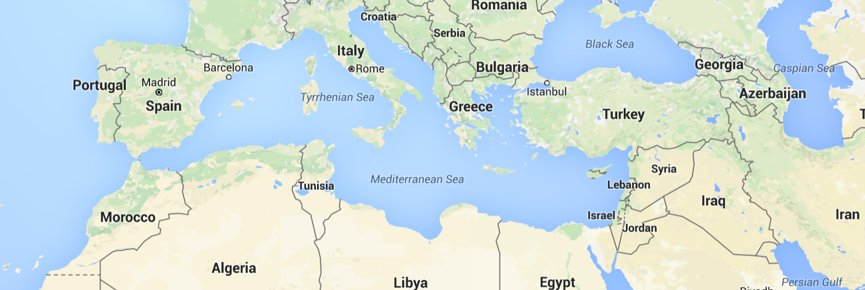

The wilderness was also mentioned as: “*go forth into the wilderness, yea, into that quarter where there never had man been.”* Civilization had spread east and north as described in Genesis, but not west in northern Africa.

[Ether 2:13](https://www.lds.org/scriptures/bofm/ether/2.13?lang=eng#12)

And now I proceed with my record; for behold, it came to pass that the Lord did bring Jared and his brethren forth even to that great sea which divideth the lands. And as they came to the sea they pitched their tents; and they called the name of the place Moriancumer; and they dwelt in tents, and dwelt in tents upon the seashore for the space of four years.

The direction was west until they reached the great Atlantic sea separating them from their destination. They were about as close to the departure of Columbus as anyone could imagine—just across the Straits of Gibraltar south of Spain. If you were to compare the destinations of the two voyages, they would almost be identical. It took a *great sea which divideth the lands.* This could not be Asia as Nibley assume a land of many lakes—contrary to a great sea.

They *dwelt in tents upon the seashore for the space of four years*. In order to find lumber to build eight barges by a seashore would halve to be south of Tangier, perhaps as far as Casablanca. If they followed the coastline, it was probably just south of Tangier but close to a forest. This would be the ancient Moriancumer where they dwelt in tents for four years.

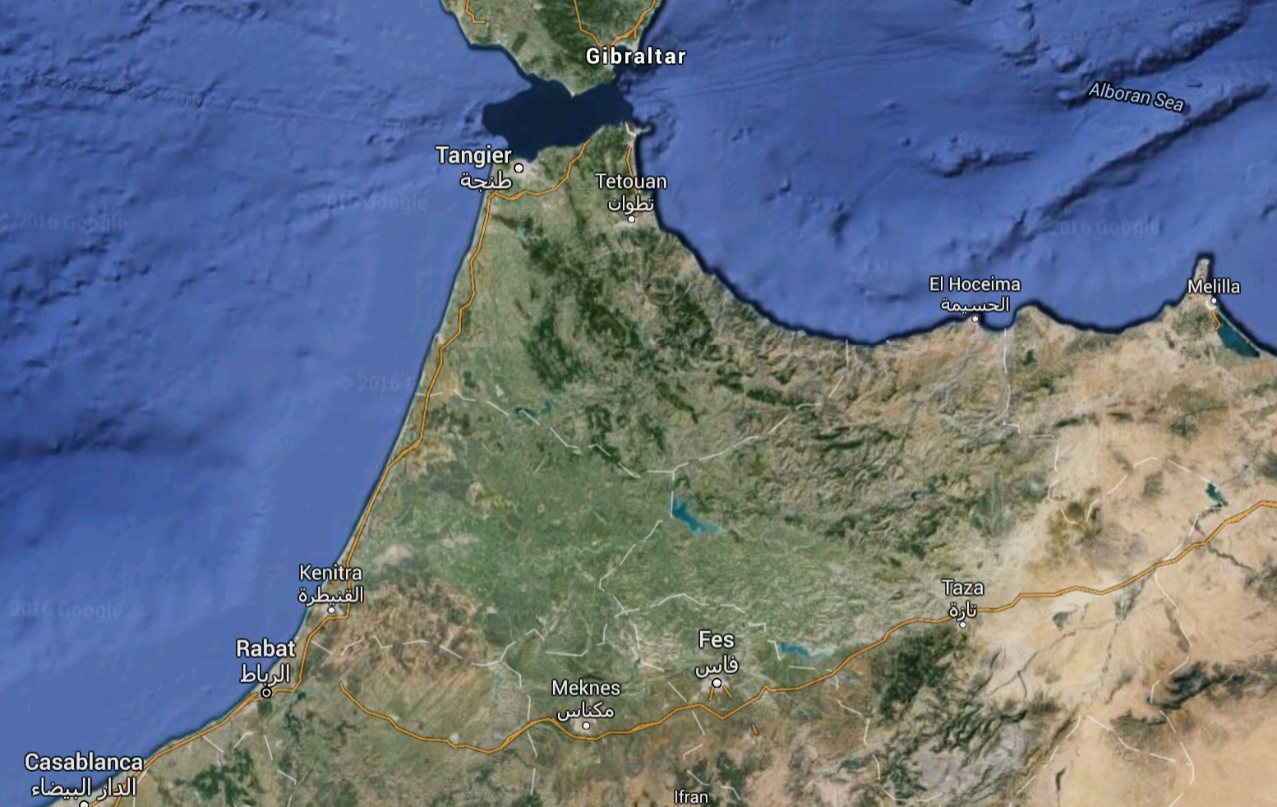

The same currents that took Columbus from Spain to the Canary Islands, south until the currents then Columbus west to Islands in the Gulf, would take the Jaredites to Central America—the place of many pyramid concepts. It would make sense that the Jaredites took the same path starting at the North West corner of Africa. Working backwards, according to the Book of Mormon would put the Jaredites precisely and the Great Pyramid.

[Ether 2:16-17](https://www.lds.org/scriptures/bofm/ether/2.16?lang=eng#15)

And the Lord said: Go to work and build, after the manner of barges which ye have hitherto built. And it came to pass that the brother of Jared did go to work, and also his brethren, and built barges after the manner which they had built, according to the instructions of the Lord. And they were small, and they were light upon the water, even like unto the lightness of a fowl upon the water.

And they were built after a manner that they were exceedingly tight, even that they would hold water like unto a dish; and the bottom thereof was tight like unto a dish; and the sides thereof were tight like unto a dish; and the ends thereof were peaked; and the top thereof was tight like unto a dish; and the length thereof was the length of a tree; and the door thereof, when it was shut, was tight like unto a dish.

Noah was at sea for one year. The Jaredites were at sea for 340 days:

[Ether 6:8-11](https://www.lds.org/scriptures/bofm/ether/6.8-11?lang=eng#7)

And it came to pass that the wind did never cease to blow towards the promised land while they were upon the waters; and thus they were driven forth before the wind.

 …And thus they were driven forth, three hundred and forty and four days upon the water.

Because of the wind and perhaps the difficult waters, the Lord had them build tight closed vessels with stones, touched by the finger of the Lord, to give them light. This is hard to understand or accept by many, but the conditions of the sea where perhaps different than with Noah. This suggests knowledge of the Lord is not as magical as some would try to ascertain other than the light in the stores. Man would not have this knowledge. Building the pyramid took knowledge that man has trouble understanding to this day.

Early in the morning on October 12, 1492, a sailor looked out to the horizon from the bow of his sailing ship, the Pinta, and saw land. After 10 long weeks at sea, from the port of Palos, Spain, Columbus and his crews saw the New World ([Google](http://www.americaslibrary.gov/jb/colonial/jb_colonial_columbus_1.html))

Comparing this to Columbus, which took only 10 weeks—a little less than four months or about a quarter of the time, tells us that the use of sails can make a difference. This is knowledge that perhaps the Jaredites did not have and could not therefore construct by simple instructions. The Lord needs man to have sufficient knowledge.

You cannot fit this scenario to any other origin than the higher elevation of the Great Pyramid. The Mormons go to great lengths to prove the path of the Nephites from Jerusalem to the red sea and east to the western shores of South America, but to assume an origin of the Jaredites to be the same does not fit.

If we compare this with Lehi’s rout from Jerusalem to South or Central America, things get much more tricky. This website is interesting, but assumes a natural ship of the time and a different rout than traditional taught by early Mormon theories. An image from the site is inserted below.

<http://www.firmlds.org/feature.php?id=15>

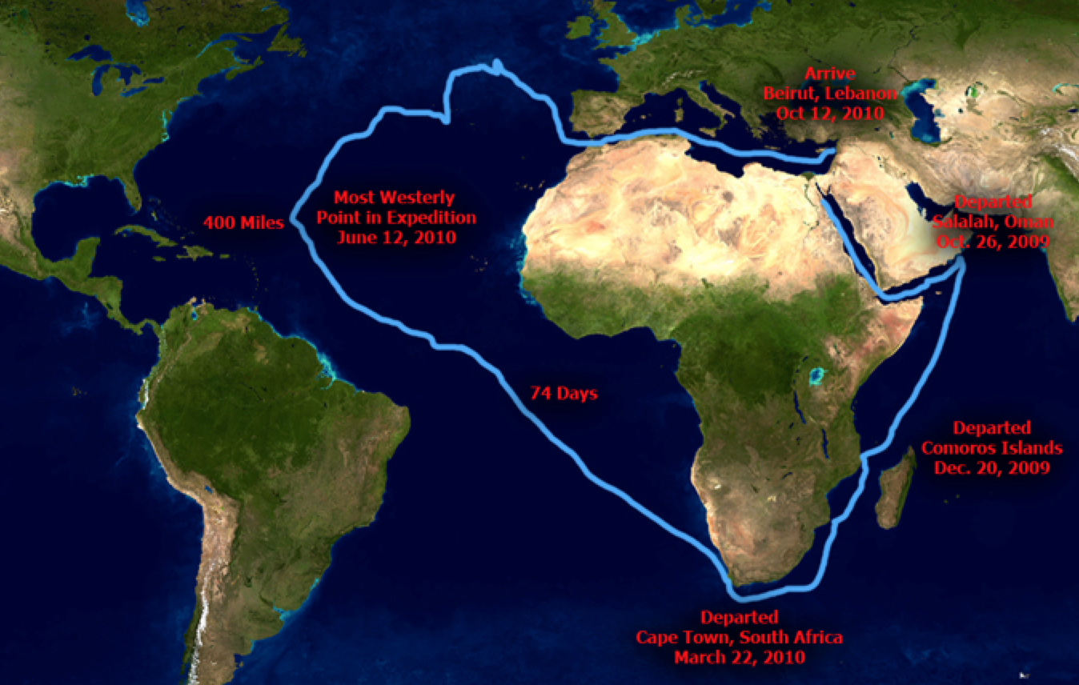

The above is actual path of vessels used at the time of Mediterranean Travels in our day. It is more reasonable than crossing the larger Pacific Ocean because it come within 400 miles of the Americas. Note the last part of the drifting into the Mediterranean—most certainly the last of Noah’s rout. The departure is precisely the area of the departure of Lehi, but takes a rout around Africa. It is just less than one year and only 74 days from the tip of Africa to 400 miles from the destination. The web site gives much more information. It would be interesting to study this more when it comes to the time of Jerusalem 400 years before Christ.

This would necessitate a Jaredite rout similar to the Lehi, but the Jaredites would land in Baja Mexico rather than South America. Mormon scholars give the Jaredites a west-to-east direction from the great tower. Using terms from the Book of Mormon this is their illustration:

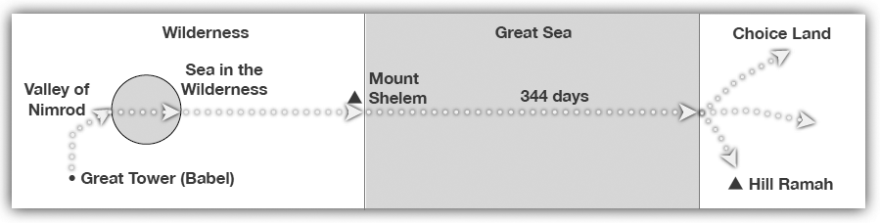

If we reverse the direction, because the Book of Mormon does not give a direction, the Sea in the Wilderness becomes the Mediterranean from the Great Pyramid. There is no travel across the sea. Even the Book of Mormon does not mentioned. It comes from interpreting the words *beyond the sea* to be across rather than further alone the sea shore. Would not the concept of a sea be the sea as it comes against the shore. No one can see the other side of the sea so beyond does not make sense. Do to the fact that they traveled in the wilderness after mentioning *beyond the sea,* the above is incorrect. The path should be along the southern part of the sea. If they could see the other side, they would use *across—*if not they would use beyond the current point of the sea like *down yonder* in modern slang. Continuing further *the Lord would not suffer that they should stop beyond the sea in the wilderness.* This is confusing if interpreted as across the sea. The Lord did not want them to stop, but to continue. This agrees more with *beyond the Mediterranean Sea in the wilderness* to the Atlantic Ocean. Either the Lord knew or the Jaredites related to this after accomplishing the task instructed. If you think like the Lord you would picture beyond the curren sea as to another great sea.

Mount Shelem would be in north west corner of Africa. After crossing the Atlantic west the Hill Ramah would be in the Maya Region from Sierra Madre to northern Yucatán and further west we have later pyramids in Teotihuacan, which represent a far more logical place for the Jaredites to land on the eastern shores of current day Yucatán Mexico. Note the pointing of an arrow north to *choice land.* This comes from tradition that the Choice Land is North America. Choice land at the time was any land of freedom. This map should have nothing to do with the Nephite travels for the Jaredites fell into darkness in Central America and not north.

We can now surmise that the Mayan calendar came by way of the Jaredites—having a closer source to Noah and Egypt. This would explain the astrological knowledge of ancient Mexico—including the 365.25 year cycle that both Egypt and ancient Mexico had.

You will not find megalith pyramids in Mesopotamia or Baja, yet pyramids set Central America equal to that of Egypt. Again, linear tradition colors our knowledge and our ability to think relationally. The Jaredites did leave a record of their history from Adam down. A later people, called the Nephites, obtained this record and Mormon gave it to us at the end of the Book of Mormon. Mormon did not give all. He was instructed not to—a common event in the Book of Mormon.

The Jaredites took a path similar to Columbus. The only difference is timing due to the type of craft built three thousand years before.